- Operating System It’s OS agnostic. We can run Praecepta on any OS [Unix/Linux, Windows or Mac etc]
- Number of Cores/CPU 2 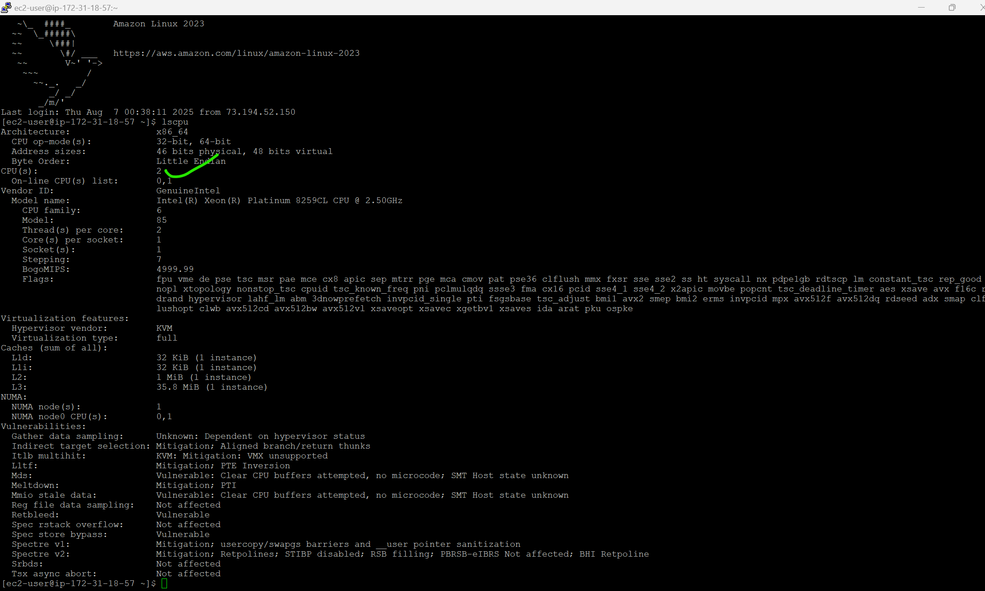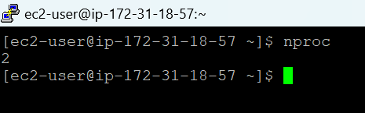
- RAM/Memory 2GB is ideal. It can run with 1GB allocation as well. 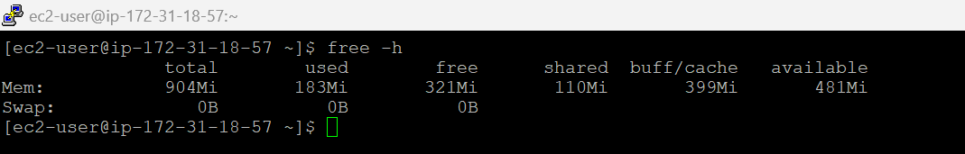
- Disk Space 8GB 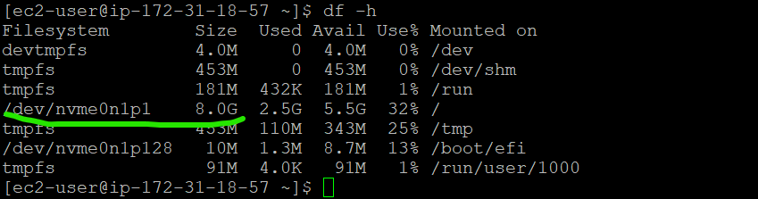
- Port Required to Open Default port is 4567 or at the application bootstrap we can assign any dedicated [8080 etc] tcp port 

